
KeyFeatures:
A Fast Growth StandFast® Alfalfa for the aggressive alfalfa manager to maximize each season’s harvestable yield.
Genetic Background:
A synthetic variety developed from the crossing of fast growing, tall European alfalfas onto elite fall dormancy 4 North American plants. Screened for persistence, high yield and forage quality.
Fall Dormancy Rating: 4.0
Winter Hardiness Index: 1.5
Field Appearance at Bud Stage:
A medium tall, leafy variety that reaches harvest maturity 3-5 days ahead of conventional dormant alfalfa varieties. Medium dark green plant color.
Multifoliate Leaf Expression:
Rated Low Multifoliate Leaf Expression at 29% and a 1.31 Multifoliate Index compared to the check variety Proof at 3.35

Variety Profile

Trifecta II Alfalfa

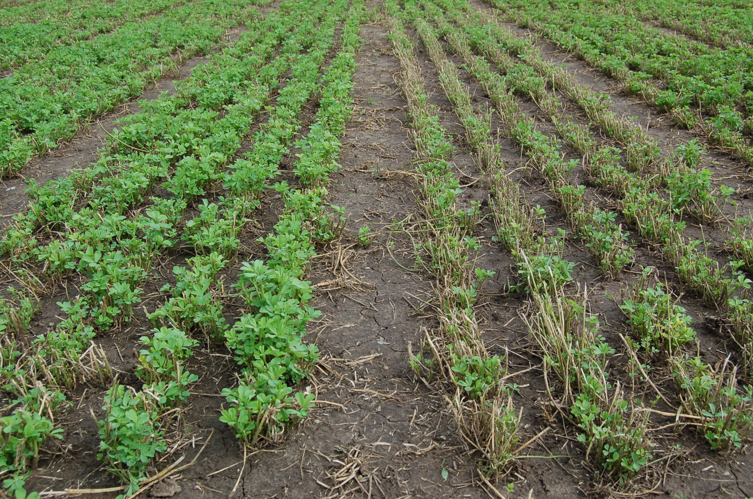

Pest Package:
Diseases:
Anthracnose………….. 62 % HR
Aphanomyces Race 1 .... 59% HR
Bacterial Wilt………….. 68% HR
Fusarium Wilt……….…. 59% HR
Phytophthora……….….. 72% HR
Verticillium Wilt………. 58% HR

Insects:
Pea Aphid………….... 55 % R
Spotted Alfalfa Aphid. 15 % MR

Stem ……………….... __ %
Northern Root Knot….. 62% HR

Nematodes:

Management Keys:
An alfalfa for the aggressive alfalfa manager whose goal is to maximize harvestable forage yield from each acre. A StandFast® Fast Growth alfalfa for all U.S. and Canadian production zones where fall dormancy 3, 4 or 5 alfalfas are recommended. Fits 4 or 5 cut harvest management systems. Rotation grazing. No known soil type or management limitations.

Marketing Information:
A StandFast® variety named Pillar for exclusive U.S. and Canadian licensing. Introductory commercial quantities available. All ratings are based on NAAIC protocol. This information is not for republication or distribution without the consent of Cal/West Seeds.
January 2010
Wheel Traffic:
Under a 5 cut harvest system with traffic pressure after each cut, CW 34029 had a 9% yield advantage over the check variety Ameristand 403T.
Fast Growth Rating:
CW 34029 has a growth rate exceeding 2.00 cm per day and is rated Fast. A standard test
protocol for measuring alfalfa rate of growth is being developed by Cal/West Seeds for NAAIC review.
Yield Performance:
CW 34029 is a new variety that has been entered in yield trials since 2004. See the attached Head to Head Yield report for comparisons.
Forage Quality:
See the attached report for quality comparisons to commercial check varieties.

